OUR REGION ON A 3D TOUR

Topic : Our regions and its landscapes , cities, monuments, interesting places or vegetacion

1. First step

Downloud and install Google Earth pro on your computer. Sign in with your Google account and then, let´s start playing!

5. My Tour
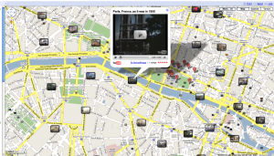
Using Internet try to find nice places from your region. Research information, pictures or videos about them. Select at least 6 places to be part of your tour that you will be explaining to your class

6. Create a new folder ( Nueva Carpeta) on GoogleEarth
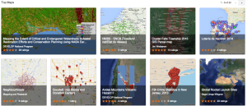

Your new folder should contain all new points that you will create on your tour
(Punto 1, Punto 2, Punto 3, etc) with a pin on it !

7. Play and save your tour
Here is your route created and your are going to play it as a 3D animation. Your digital route will be so cool that you would love to do it in real life!

8. Sharing with your class

After your task is finished, you will be presenting you 3D route to your classmates in English.
Your teacher will be giving you a rewarding mark for your intensive work!!

